SystemWORKS  Training Sample | Appendix
SystemWORKS  Training Sample | F

FileONE has included both a sample training overview for SystemWORKS, as well as a SOSKB training plan delivered for the Pennsylvania Secretary of State. Please note that FileONE’s entire response in Appendix F, “SystemWORKS™ Training Sample” has been marked as confidential. FileONE’s response in Appendix F contains detailed proprietary data and trade secrets, and confidential product information, which FileONE makes every effort to protect. We respectfully request the ND SOS hold this entire Appendix F as confidential.
Table of Contents
Configuring Entity Lookup Tables 1
Configuring Address Types 1
Configuring Email Types 2
Configuring Phone Types 2
Editing Entity Lookup Tables 3
Resequencing Rows in Entity Lookup Tables 3
Configuring Lien Lookup Tables 5
Configuring Lien Types 6
Configuring Filing Types 6
Configuring Amendment Types 7
Configuring Alternate Filing Types 8
Configuring Amendment Actions 9
Configuring Alternative Designations 10
Editing Lien Lookup Tables 11
Resequencing Rows in Liens Lookup Tables 11
Configuring Liens Lists 13
Configuring Special Characters Lists 13
Configuring Noise Words 13
Configuring Restricted Collateral Phrases 14
Configuring Restricted Debtor Names 14
Editing Lien Lists 15
Resequencing Rows in Lists 15

Configuring Entity Lookup Tables
Entity lookup tables are used to configure certain entity values. Once these values have been defined, they can then be used in drop-down boxes in the SystemWorks UI. The following is a list of the Entity lookup tables:
- Address Types
- Email Types
- Phone Types

Configuring Address Types
The Address Types lookup table allows a System Administrator to configure address types for each line of business. Once these values have been defined, they can then be used in drop-down boxes in the SystemWorks UI.

To configure an address type:
- Select Administrative >> Data Administration >> Lookup Tables.
- Select the Entity tab.
- Select the Address Type link.
The Address Type data entry grid displays. The data entry grid is shown below.

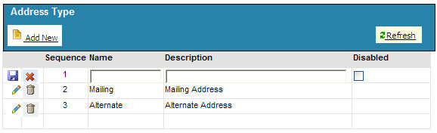

- Select Add New to display editable data entry fields.
- Select address type from the Name drop-down list. The drop-down values include:

- Mailing
- Alternate
- Legal
- Main Office
- Principal Office
- Registered Agent
- UCC Address

- Select the appropriate Description from the drop-down list.
- Select the Disabled checkbox if the address type should not be displayed.
- Select the Save () icon to save the address type information to the database and to generate a new Sequence number.
- Select the Cancel () icon to cancel the changes.

Configuring Email Types
The Email Types lookup table allows a System Administrator to configure email types for each line of business. Once these values have been defined, they can then be used in drop-down boxes in the SystemWorks UI.

To configure an email type:
- Select Administrative >> Data Administration >> Lookup Tables.
- Select the Entity tab.
- Select the Email Type link.
The Email Type data entry grid displays. The data entry grid is shown below.

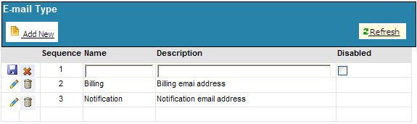

- Select Add New to display editable data entry fields.
- Select an email type from the Name drop-down list. Email types include:

- Billing
- Email
- Primary Email
- Notification Email

- Enter a description in the Description text box.
- Select the Disabled checkbox if the email type should not be displayed.
- Select the Save () icon to save the address type information to the database and to generate a new Sequence number.
- Select the Cancel () icon to cancel the changes.

Configuring Phone Types
The Phone Types lookup table allows a System Administrator to configure phone types for each line of business. Once these values have been defined, they can then be used in drop-down boxes in the SystemWorks UI.

To configure a phone type:
- Select Administrative >> Data Administration >> Lookup Tables.
- Select the Entity tab.
- Select the Phone Type link.
The Phone Type data entry grid displays. The data entry grid is shown below.

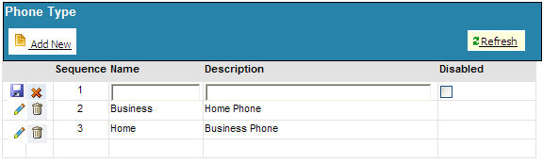

- Select Add New to display editable data entry fields.
- Select email type from the Name drop-down list. Phone types include:

- Business
- Mobile
- Home
- Fax

- Enter a description in the Description text box.
- Select the Disabled checkbox if the address type should not be displayed.
- Select the Save () icon to save the address type information to the database and to generate a new Sequence number.
- Select the Cancel () icon to cancel the changes.

Editing Entity Lookup Tables
Previously defined items in the Lien lookup tables may need to be redefined or are no longer needed.

To edit entity lookup table settings:
- Select the Administrative tab >> Data Administration >> Lookup Tables
- Select the Entity tab.
- Select one of the links in the first column.
- Select the edit () icon next to the row of settings you want to change.
- Configure the new settings.
- Select the Save () icon to save the new settings.
- Select the Cancel () icon to cancel the settings.

Resequencing Rows in Entity Lookup Tables
The number in the No. column in the data entry grid corresponds to where the list item will appear in the drop-down list on the screen. For example, if there is a 3 in the No. column next to the word Corp., Corp. will appear as the third item in the list. When selecting the Add New option to add a new item to the data entry grid, that new item's number becomes 1, and the rest of the items in the grid move down and are renumbered. There may be times when one of the list items may need to be moved to another position in the list. This is referred to as resequencing. Resequencing is performed by dragging and dropping rows.

To resequence an item in a lookup table:
- Select the Administrative tab >> Data Administration >> Lookup Tables
A tabbed data entry grid displays.
- Select the Liens tab.
A table displays with several links in the first column.
- Select one of the links.
- Move the mouse pointer over the row of the item you want to move and click the left mouse button.
- Holding down the left mouse button drag the item up or down in the list until it's in the correct position.
- Release the left mouse button.
The item is dropped into its new position and renumbered accordingly. All other items are renumbered if necessary.

Note: Only one row can be resequenced at a time.

Configuring Lien Lookup Tables
Lien lookup tables are used to configure certain lien values. Only a FileONE Administrator can add values to and delete values from most of the tables. The jurisdiction's System Administrator can view the tables, edit the descriptions, and enable/disable the values. Once these values have been defined, they can then be used in drop-down boxes in the SystemWorks UI. The following table lists the associated lien lookup tables and the privileges associated with the lookup table options.

Lien Lookup Table Name | Add New | Delete | Edit Name | Edit Description | Enable/Disable
Lien Type | FileONE Administrator | FileONE Administrator | FileONE Administrator | FileONE Administrator/System Administrator | FileONE Administrator/System Administrator
Filing Type | FileONE Administrator | FileONE Administrator | FileONE Administrator | FileONE Administrator/System Administrator | FileONE Administrator/System Administrator
Amendment Type | FileONE Administrator | FileONE Administrator | FileONE Administrator | FileONE Administrator/System Administrator | FileONE Administrator/System Administrator
Amendment Action | FileONE Administrator | FileONE Administrator | FileONE Administrator | FileONE Administrator/System Administrator | FileONE Administrator/System Administrator
Alternative Designations | FileONE Administrator/  System Administrator | FileONE Administrator/  System Administrator | FileONE Administrator/  System Administrator | FileONE Administrator/System Administrator | FileONE Administrator/System Administrator
Alt Filing Type | FileONE Administrator | FileONE Administrator | FileONE Administrator | FileONE Administrator/System Administrator | FileONE Administrator/System Administrator
Lien Search Report | FileONE Administrator | FileONE Administrator | FileONE Administrator | FileONE Administrator/System Administrator | FileONE Administrator/System Administrator

The Lien Lookup table data grid is shown below:

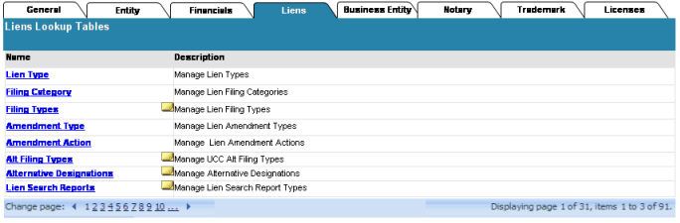

Configuring Lien Types
The Lien types lookup table allows the FileONE Administrator to add UCC Lien types to the table. These Lien types descriptions will then be used in various drop-down lists on SystemWorks screens. The SystemWorks™ application will provide some preconfigured Lien types.

To configure a lien type:
- Select the Administrative tab >> Data Administration >> Lookup Tables
A tabbed data entry grid displays.
- Select the Liens tab.
A data grid displays with several links in the first column.
- Select the Lien Type link.
The Lien Type data entry grid displays. The data grid is shown below:
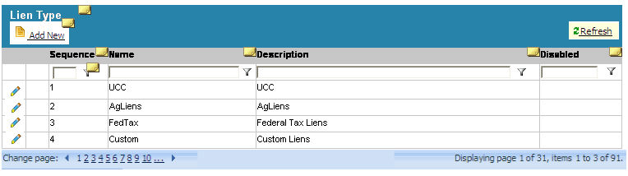
- Select Add New to display editable data entry fields.
- Enter a Name and a Description.
- Select the Disabled checkbox if the Lien type should not be displayed.
- Select the Save () icon to save the address type information to the database and to generate a new Sequence number.
- Select the Cancel () icon to cancel the changes.
- Select Refresh () to view new configurations made by another FileONE or System Administrator without having to reload the page.

Note: The data entry grid displays 20 rows at a time. If there are more rows to view, select one of the Change Page numbers at the bottom left of the grid or select the back arrow () icon or forward arrow () icon to move between the pages. The lower right corner displays the page of pages, as well as the number of items on the page and the total number of items.

Configuring Filing Types
The Filing types lookup table allows the FileONE Administrator to add UCC filing types to the table. These filing types descriptions will then be used in various drop-down lists on SystemWorks screens. The SystemWorks™ application will provide some preconfigured filing types.

To configure a filing type:
- Select the Administrative tab >> Data Administration >> Lookup Tables
A tabbed data entry grid displays.
- Select the Liens tab.
A data grid displays with several links in the first column.
- Select the Filing Types link.
The Filing Types data entry grid displays. The data grid is shown below:
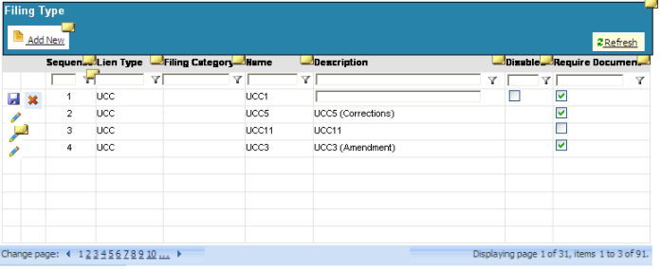
- Select Add New to display editable data entry fields.
- Enter a Lien Type, Name, and Description.
- Select the Disabled checkbox if the filing type should not be displayed.
- Select the Required Document checkbox if an electronic image of the document needs to be available before the system accepts the filing.
- Select the Save () icon to save the address type information to the database and to generate a new Sequence number.
- Select the Cancel () icon to cancel the changes.
- Select Refresh () to view new configurations made by another system administrator without having to reload the page.

Note: The data entry grid displays 20 rows at a time. If there are more rows to view, select one of the Change Page numbers at the bottom left of the grid or select the back arrow () icon or forward arrow () icon to move between the pages. The lower right corner displays the page of pages, as well as the number of items on the page and the total number of items.

Configuring Amendment Types
An amendment is filed to record and give public notice regarding changes to a filed financing statement. These filings may be used to record changes to collateral or the names/addresses of debtors or secured parties, or be used to correct errors in original financing statements. The Amendment types lookup table allows the FileONE Administrator to add amendment types to the table. These amendment types descriptions will then be used in various drop-down lists on SystemWorks screens. The SystemWorks™ application will provide some preconfigured amendment types.

To configure an amendment type:
- Select the Administrative tab >> Data Administration >> Lookup Tables
A tabbed data entry grid displays.
- Select the Liens tab.
A data grid displays with several links in the first column.
- Select the Amendment Types link.
The Amendment Types data entry grid displays. The data grid is shown below:
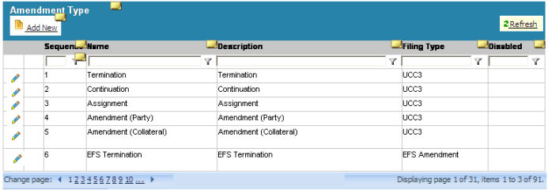
- Enter a Name and Description for the amendment type.
- Select a Filing Type from the drop-down list.
- Select the Disabled checkbox if the Lien type should not be displayed.
- Select the Save () icon to save the address type information to the database and to generate a new Sequence number.
- Select the Cancel () icon to cancel the changes.
- Select Refresh () to view new configurations made by another FileONE or System Administrator without having to reload the page.

Note: The data entry grid displays 20 rows at a time. If there are more rows to view, select one of the Change Page numbers at the bottom left of the grid or select the back arrow () icon or forward arrow () icon to move between the pages. The lower right corner displays the page of pages, as well as the number of items on the page and the total number of items.

Configuring Alternate Filing Types
Alternate filing types are filing types that are not related to UCC filings. The alternate filing type lookup table allows the FileONE Administrator to add alternate filing types to the table. The alternate filing type descriptions will then be used in various drop-down lists on SystemWorks screens. The SystemWorks™ application will provide some preconfigured alternate filing types.

To configure an alternate filing type:
- Select the Administrative tab >> Data Administration >> Lookup Tables
A tabbed data entry grid displays.
- Select the Liens tab.
A data grid displays with several links in the first column.
- Select the Alt Filing Types link.
The Alt Filing Types data entry grid displays. The data grid is shown below:
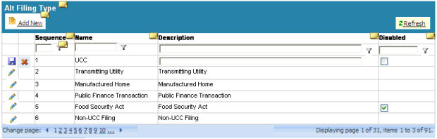
- Enter a Name and Description for the amendment action.
- Select the Disabled checkbox if the Lien type should not be displayed.
- Select the Save () icon to save the alternate filing type information to the database and to generate a new Sequence number.
- Select the Cancel () icon to cancel the changes.
- Select Refresh () to view new configurations made by another FileONE or System Administrator without having to reload the page.

Note: The data entry grid displays 20 rows at a time. If there are more rows to view, select one of the Change Page numbers at the bottom left of the grid or select the back arrow () icon or forward arrow () icon to move between the pages. The lower right corner displays the page of pages as well as the number of items on the page and the total number of items.

Configuring Amendment Actions
An amendment action specifies what action needs to be taken for the amendment being filed. The Amendment actions lookup table allows the FileONE Administrator to add amendment actions to the table. These amendment action descriptions will then be used in various drop-down lists on SystemWorks screens. The SystemWorks™ application will provide some preconfigured amendment actions.

To configure an amendment action type:
- Select the Administrative tab >> Data Administration >> Lookup Tables
A tabbed data entry grid displays.
- Select the Liens tab.
A data grid displays with several links in the first column.
- Select the Amendment Types link.
The Amendment Types data entry grid displays. The data grid is shown below:
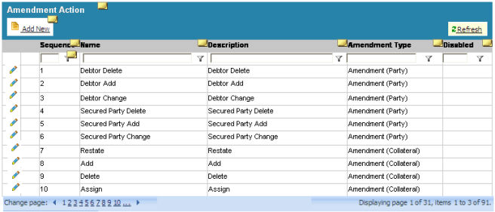
- Enter a Name and Description for the amendment action.
- Enter an Amendment Type from the drop-down list. This list was populated by the Amendment Types defined in the Amendment Type data grid.
- Select the Disabled checkbox if the Lien type should not be displayed.
- Select the Save () icon to save the address type information to the database and to generate a new Sequence number.
- Select the Cancel () icon to cancel the changes.
- Select Refresh () to view new configurations made by another FileONE or System Administrator without having to reload the page.

Note: The data entry grid displays 20 rows at a time. If there are more rows to view, select one of the Change Page numbers at the bottom left of the grid or select the back arrow () icon or forward arrow () icon to move between the pages. The lower right corner displays the page of pages as well as the number of items on the page and the total number of items.

Configuring Alternative Designations
Alternative designations specify the alternate relationship of the Secured Party to the Debtor. The alternate filing type lookup table allows the System Administrator to add alternate filing types to the table. The alternate filing type descriptions will then be used in various drop-down lists on SystemWorks screens. The SystemWorks™ application will provide some preconfigured amendment actions.

To configure an alternative designation type:
- Select the Administrative tab >> Data Administration >> Lookup Tables
A tabbed data entry grid displays.
- Select the Liens tab.
A data grid displays with several links in the first column.
- Select the Alternative Designation link.
The Alternative Designation data entry grid displays. The data grid is shown below:
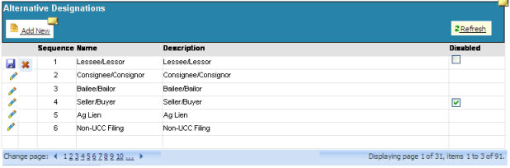
- Enter a Name and Description for the amendment action.
- Select the Disabled checkbox if the Lien type should not be displayed.
- Select the Save () icon to save the alternate filing type information to the database and to generate a new Sequence number.
- Select the Cancel () icon to cancel the changes.
- Select Refresh () to view new configurations made by another FileONE or System Administrator without having to reload the page.

Note: The data entry grid displays 20 rows at a time. If there are more rows to view, select one of the Change Page numbers at the bottom left of the grid or select the back arrow () icon or forward arrow () icon to move between the pages. The lower right corner displays the page of pages, as well as the number of items on the page and the total number of items.

Editing Lien Lookup Tables
Previously defined items in the Lien lookup tables may need to be redefined or are no longer needed.

To edit lien lookup table settings:
- Select the Administrative tab >> Data Administration >> Lookup Tables
- Select the Liens tab.
- Select one of the links in the first column.
- Select the edit () icon next to the row of settings you want to change.
- Configure the new settings.
- Select the Save () icon to save the new settings.
- Select the Cancel () icon to cancel the settings.

Resequencing Rows in Liens Lookup Tables
The number in the No. column in the data entry grid corresponds to where the list item will appear in the drop-down list on the screen. For example, if there is a 3 in the No. column next to the word Corp., Corp. will appear as the third item in the list. When selecting the Add New option to add a new item to the data entry grid, that new item's number becomes 1, and the rest of the items in the grid move down and are renumbered. There may be times when one of the list items may need to be moved to another position in the list. This is referred to as resequencing. Resequencing is performed by dragging and dropping rows.

To resequence an item in a lookup table:
- Select the Administrative tab >> Data Administration >> Lookup Tables
A tabbed data entry grid displays.
- Select the Liens tab.
A table displays with several links in the first column.
- Select one of the links.
- Move the mouse pointer over the row of the item you want to move and click the left mouse button.
- Holding down the left mouse button drag the item up or down in the list until it's in the correct position.
- Release the left mouse button.
The item is dropped into its new position and renumbered accordingly. All other items are renumbered, if necessary.

Note: Only one row can be resequenced at a time.

Configuring Liens Lists
Liens are a form of security interest granted over an item of property to secure the payment of a debt or performance of some other obligation. These lists are a set of rules that are applied to a filing when the filing is processed. These rules ensure that the filing adheres to the jurisdiction's business rules. . The user can add a new entry, edit an existing entry, delete an entry, or enable/disable an entry in a particular list. However, a user cannot add a new or delete an existing tabbed category. Lists that are specific to liens that are configurable include:

- Special search characters
- Noise words
- Restricted collateral phrases
- Restricted Debtor names

Configuring Special Characters Lists
This feature configures how special characters are to be converted during a Lien search. For example the "&" sign would be converted to the word "and". The SystemWorks application comes configured with the standard RA9 special character conversions. The System Administrator can add any other special characters that are used by their jurisdiction.

To add a special character to a list:
- Select the Administrative tab >> Data Administration >> Lists
A tabbed window displays.
- Select the Liens tab.
- Select the Search Special Characters link.
- Select Add New
A new editable row displays in the data grid.
- Enter the character in the Character text box. The Character text box is a required field.
- Enter the word or words to be used to replace the special character. If this text box is left blank, the special character defined in the Character text box will be stripped from the search.
- Select the Disabled check box if you want the special character disabled.
- Select the Save () icon to save the special character information to the database.
- Select the Cancel () icon to cancel the changes.

Note: The No. is automatically generated by the system when the Save () icon is selected.

Configuring Noise Words
"Noise words" are strings or specific characters to ignore when performing a UCC search. Words to ignore may include Corp., and, to, etc. SystemWorks will provide some out-of-the-box noise words. However, each jurisdiction can configure their own list.

To configure a noise word:
- Select the Administrative tab >> Data Administration >> Lists
A tabbed data entry grid displays.
- Select the Liens tab.
A table displays with several links in the first column.
- Select the Noise Words link.
- Select Add New
A new editable row displays in the data grid.
- Type the noise word in the Noise Word text box.
- From the Ignore system-wide drop-down box, select whether the word should be ignored at the start of the phrase, at the end of the phrase, or anywhere in the phrase.
- From the Ignore by user drop-down box, select whether the word should be ignored at the start of the phrase, at the end of the phrase, or anywhere in the phrase.
- Select the Disabled checkbox if the word should not be ignored.
- Select the Save () icon to save the special character information to the database.
- Select the Cancel () icon to cancel the changes.

Note: The No. is automatically generated by the system when the Save () icon is selected.

Configuring Restricted Collateral Phrases
Restricted collateral phrases refers to items that cannot be used as collateral when filing a UCC document. For example, driver's licenses, birth certificates, etc. SystemWorks will provide some out-of-the-box restricted collateral phrases. However, each jurisdiction can configure their own list.

To configure a restricted collateral phrase:
- Select the Administrative tab >> Data Administration >> Lists
A tabbed data entry grid displays.
- Select the Liens tab.
- Select the Restricted Collateral Phrases link.
- Select Add New
A new editable row displays in the data grid.
- Type the restricted collateral phrase in the Restricted Collateral Phrase text box.
- Select the Disabled checkbox if the item can be used as collateral.
- Select the Save () icon to save the restricted collateral phrase information to the database.
- Select the Cancel () icon to cancel the changes.

Note: The No. is automatically generated by the system when the Save () icon is selected.

Configuring Restricted Debtor Names
Restricted debtor names refers to names that cannot be used for debtors when filing a UCC document. For example, George W. Bush or Abe Lincoln may be in the list of restricted debtor names. SystemWorks will provide some out-of-the-box restricted debtor names. However, each jurisdiction can configure their own list.

To configure a restricted debtor name:
- Select the Administrative tab >> Data Administration >> Lists
A tabbed data entry grid displays.
- Select the Liens tab.
- Select the Restricted Debtor Names link.
- Select Add New
A new editable row displays in the data grid.
- Type the restricted debtor's name in the Restricted Debtor Name text box.
- Select the Disabled checkbox if the item can be used as collateral.
- Select the Save () icon to save the restricted collateral phrase information to the database.
- Select the Cancel () icon to cancel the changes.

Note: The No. is automatically generated by the system when the Save () icon is selected.

Editing Lien Lists
Previously defined items in the Lien lists may need to be redefined or are no longer needed.

To edit entity lookup table settings:
- Select the Administrative tab >> Data Administration >> Lists
- Select the Liens tab.
- Select one of the links in the first column.
- Select the edit () icon next to the row of settings you want to change.
- Configure the new settings.
- Select the Save () icon to save the new settings.
- Select the Cancel () icon to cancel the settings.

Resequencing Rows in Lists
The number in the No. column in the data entry grid corresponds to where the list item will appear in the drop-down list on the screen. For example, if there is a 3 in the No. column next to the word Corp., Corp. will appear as the third item in the list. When selecting the Add New option to add a new item to the data entry grid, that new item's number becomes 1, and the rest of the items in the grid move down and are renumbered. There may be times when one of the list items may need to be moved to another position in the list. This is referred to as resequencing. Resequencing is performed by dragging and dropping rows.

To resequence an item in the list:
- Select the Administrative tab >> Data Administration >> Lists
A tabbed data entry grid displays.
- Select the Liens tab.
A table displays with several links in the first column.
- Select one of the links.
- Move the mouse pointer over the row of the item you want to move and click the left mouse button.
- Holding down the left mouse button drag the item up or down in the list until it's in the correct position.
- Release the left mouse button.
The item is dropped into its new position and renumbered accordingly. All other items are renumbered if necessary.

Note: Only one row can be resequenced at a time.

FileONE, inc.
Pennsylvania
SOSKB Corporations
Training Plan and Schedule

Curriculum Description 17
Pre-requisites 17

Supporting Documents 17
Module I FILEONE / SOSKB Overview 17
Module II Business Entity Profiles 17
Module III Cash Management 17
Module IV Scanning & Connecting Documents 18
Module V Workflow Processing and Event Creation 18
Module VI Corporate Online Functionality 18
Module VII Other Corp. Functions / Tips & Techniques 18
Module VIII Reporting 19
Module IX KB Administrator 19

Goals & Objectives* by Module 19
Administration 21
Durations and Schedule by Module 20
Location 22
Trainer 22
Advance Set-up 22
Other 23
Learning Method(s) 23

Curriculum Description

Pre-requisites
- Basic Microsoft Windows Skills

Supporting Documents
- User Guide
- Online SOSKB Help
- PowerPoint presentation slides
- Labs / Hand-outs
- Filing Examples (PA to provide)

FILEONE / SOSKB Overview
- About SOSKB
- KB Application Overview
  - KB Desktop Applications
  - KB Online Functionality
- Version Updates
- Help & Support

Business Entity Profiles
- Searching entities in SOSKB
  - Name Availability
  - Entity Search
  - E-Account and Quick Lookups
- Entity Creation
- Profile Definitions
- Adding a Profile
  - Entering Entity Details for specific profiles.
- Selecting and Editing Internal and External Entity Relationships
- Combining Entities
- Configuring E-accounts

Cash Management
- Entering Payments in Main Entry and Invoices
- Regarding Entity Functionality (not available at time of training)
- Credit Card Swipe functionality
- Refunds, Credit Balances and Adjustments
- Invoice Management and Billing Statements
- Creating Filing Tasks
- Rejecting a Filing in Main Entry
- Daily Close Out Procedures
  - User Closeout
  - Master Closeout

Scanning & Connecting Documents
- Scanning Procedure
- Auto Connect
  - Manually Connecting Images to Filing Tasks
- Back Scanning

Workflow Processing and Event Creation
- Processing Steps
  - KB Workflow
    - Basic Workflow Functionality
    - Document Examination
    - Rejecting a Filing in Workflow
    - Manually Checking In a Document
  - KB Main
    - Event Creation and Submission
(Partial List)
Entry and Processing
- Business Purpose
- POD
- State of Domicile (Foreign / Domestic)
- Commit Checks
- NAICS
Display Fields
- Name Expiration
- Status
- Stocks
Other
- Certificates
- Return Correspondence
    - Uncommitted Events
    - Viewing and Editing Images
    - Deleting Duplicate Filings
    - Reprinting Certificates and Acknowledgement Letters
    - Managing Pages to a Filing Image

Corporate Online Functionality
- Online Business Entity Search
- Online Corporate Orders (will utilize non-PA environment)

Other Corp. Functions / Tips & Techniques
- Folder Wizard
- Corporate Order History and other look-ups
- Corporate Orders in KB Main
- Email Notifications
- Dissolution Processing (PA specific procedure)
- Show File Stats
- Using the Folder Wizard
- Windows Techniques for KB
  - Setting Workstation Clock
  - Character Map Option
  - Tile Windows – Arranging Your Workspace

Reporting
- SOSKB Reporting Tool application and functionality
  - Aging Report
  - Error Log Report
  - Uncommitted Events
  - Other Reports
- Daily Close Out Procedures
  - User Closeout
  - Master Closeout

KB Administrator
- KB Admin Tool
- New User Setup
- Security
- KB Main / Workflow / Reports Admin. Functions
  - Initial Application Usage
- Setting User Document Ranges
- User preferences
- Proclarity Reporting
- File Stats
- Phone Lists
- B2B Account Set-up / Configuration

Goals & Objective by Module
Mod. | Goal / Objective
I | - Increased user confidence  - Ability to identify that latest version of SOSKB is properly loading  - Understanding of how to request/receive Support  - First look at end-to-end SOSKB Corporate Filing processing functionality
II | - Ability to perform basic Main Entry functions  - Understanding of Entity records, including:  - Searching  - Adding  - Deleting  - Combining  - Commercial/Personal  - E-account and setup/configuration
III | - Understanding of all Intake Phase steps  - Understanding of how to manipulate Main Entry and Invoices to accurately reflect various finance/fee related scenarios, including:  - Overpayment  - Underpayment  - Billing Statements  - Aging / Past Due  - Understanding of Financial Close-out Process(es)
IV | - Ability to scan and re-scan, to create images of Corporate Filings  - Ability to Connect images to Filing Tasks  - Ability to manipulate images after scanning  - Understanding of back-scanning steps
V | - Ability to perform Corporate Filing processing for all Filing Types  - Ability to manipulate Workflow queues
VI | - Understanding of Online Searches and Corporate Orders
VII | - Ability to speed up processing via use of SOSKB and Windows shortcuts and techniques  - Understanding of non-filing related functions  - Understanding of Dissolutions processing steps
VIII | - Ability to access and understand key SOSKB Reports
IX | - Understanding of SOSKB Administrative functions, including:  - New User set-up  - Un-committing / re-committing Filing Events  - Deleting and moving Filing Events  - Re-creating Certificates and other return correspondence  - Familiarity with SOSKB Admin application  - Understanding of ProClarity reporting tool, and Corp. OLAP cubes, including:  - Corp. production and financial summary reports

Administration

Module Durations
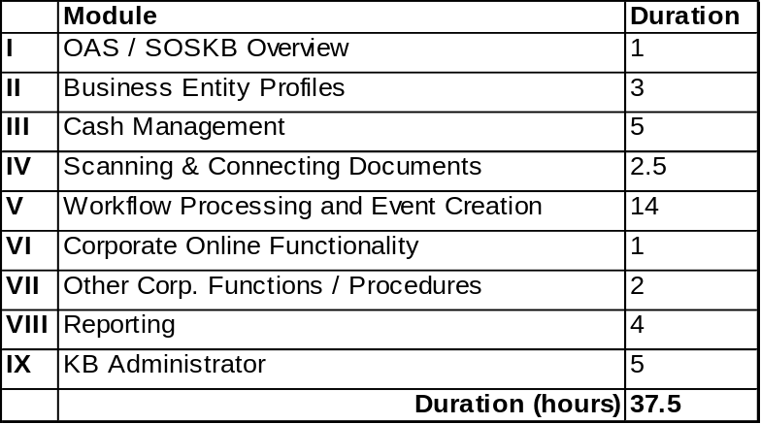

Schedule
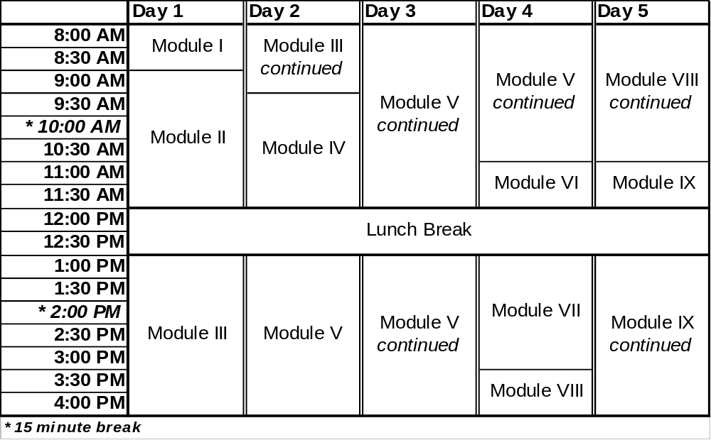

Attendee Data
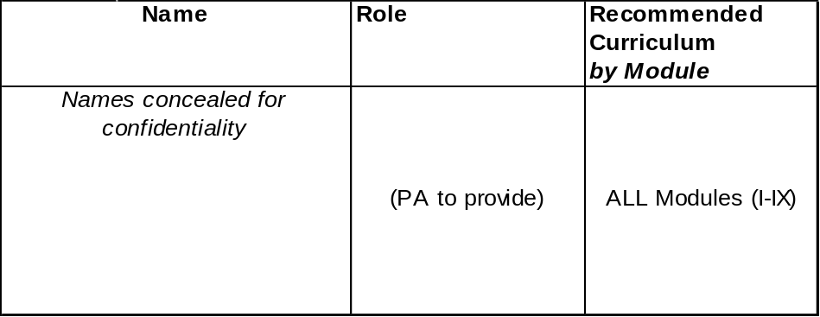

Repetitions: 4

Class size: up to 12 (per repetition)

Location
TBD (PA to provide)

Trainer
- Sebastian Dorin
Training Specialist - FileONE
(919) 844-8179 ext. 110
SDorin@FileONEinc.com
- Assistant Trainer
TBD (FILEONE to provide)

Advance Set-up

Required Hardware/software
- Projector (PA to provide)
- Workstations w/KB installed and configured (for hands-on training and exercises)
- Laptop w/required software, etc. (FILEONE will provide)

Supporting Documents
- User Guide (PA to provide hard-copy)
- Filing samples (PA to provide 2 weeks prior)
- SOSKB Help Online
- PowerPoint presentation slides
- Hand-outs, e.g. exercises and diagrams

Other

Learning Method(s)
FILEONE employs a basic but proven strategy of [instructor led training] + [hands on audience participation], with the added support of user documentation and online help system, and labs.
While structured to cover key topics and content, actual training delivery is flexible and will be adjusted to meet the needs of the specific audience as uncovered during the training process.
Actual filing examples (as provided by the customer) are used throughout so that all training has relevant context and immediate applicability.

Instruct
Hands-on / exercises w/instructor supervision

SOSKB
Developer Training Plan

Topics

SOSKB Overview / System Set-up 2 day(s)
- Walk-through of SOSKB / SOSKB set-up steps

Database Objects .5 day(s)
- Overview of databases and database objects used by SOSKB

Classes .5 day(s)
- Overview of classes used by SOSKB

Jobs & Maintenance 2 days(s)
- SOSKB jobs defined
- SOSKB maintenance procedures

Supporting Documents
- ‘Server Set-up Config.doc’
- Database diagrams
- Class diagrams
- ‘SOSKB Systems Operations.doc’

Administration

Trainer
Sebastian Dorin
Training Specialist
FileONE, Inc.

Schedule (by Module)
Mon | Tue | Wed | Thu | Fri
I |  | II, III | IV

Attendee Statistics
User Type | Number | Curriculum  (by Module)
User Type | Number | Required | Optional
Network admin. | 2 | I | IV
Developer I | 2 | All Modules
Developer II | 2 | I, IV | II, III

Venue

Location
- SOS meeting facility

Hardware
- Projector (customer will provide)
- Laptop w/required software, etc. (FileONE will provide)

Delivery-type
- Presentation

Online Help System Topic (screenshot) (non-SystemWorks™)
